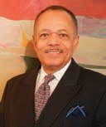
New York, NY
Church Street Station, P.O. Box 2224, New York, NY 10008-2224
Tel: 212.406.2400
Fax: 212.406.2402
Email: B@BurgessTravelAdventures.com
Website: www.BurgessTravelAdventures.com

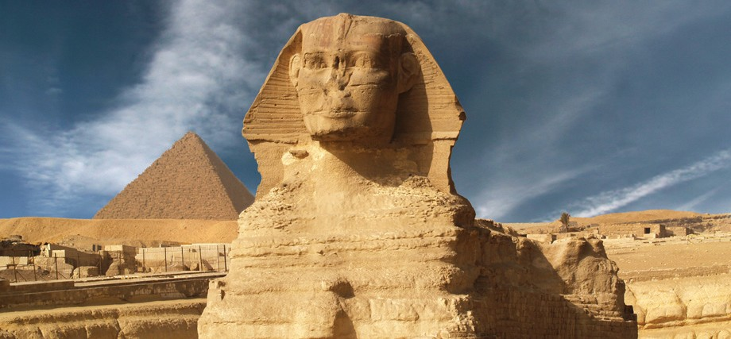
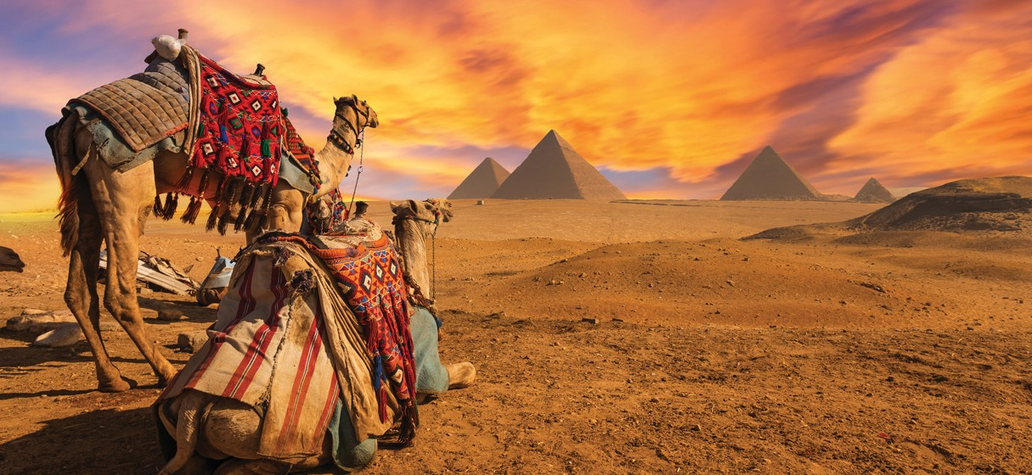
Timeless Egypt: Experience the Pyramids, Abu Simbel, Valley of the Kings and Queens, and a luxury 3-night Nile Cruise with Bill Burgess
Nov 18 – 28, 2017
$3,999/person, double occupancy Land & Air Included
10 days / 9 nights

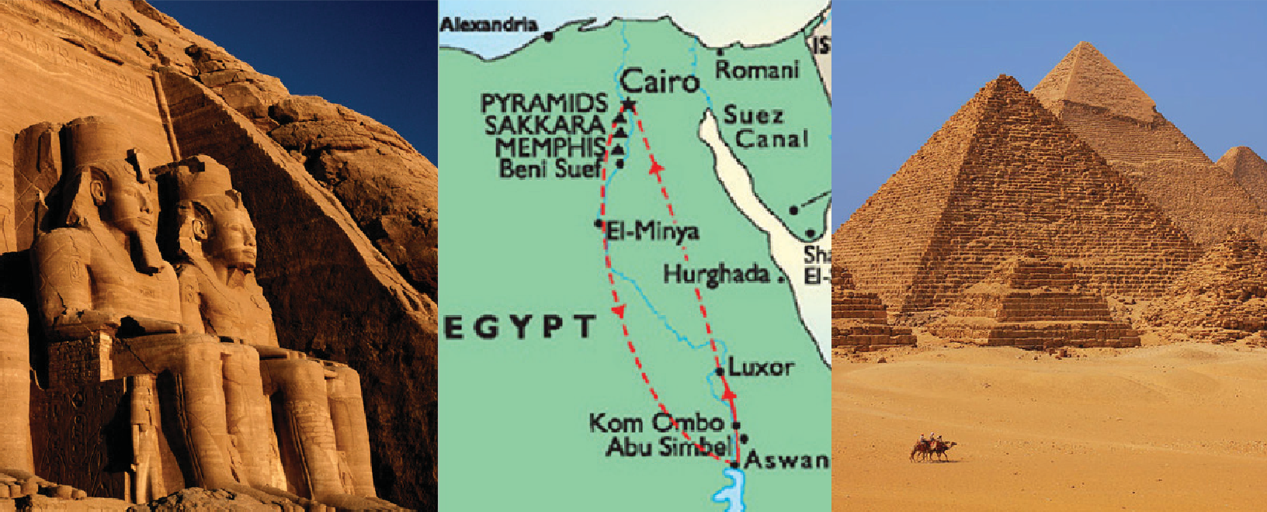Burgess Travel Adventures and Keytours Vacations
presents
“Timeless Egypt: Experience the Pyramids, Abu Simbel, Valley of the Kings and Queens, and a Luxury 3-night Nile Cruise with Bill Burgess”

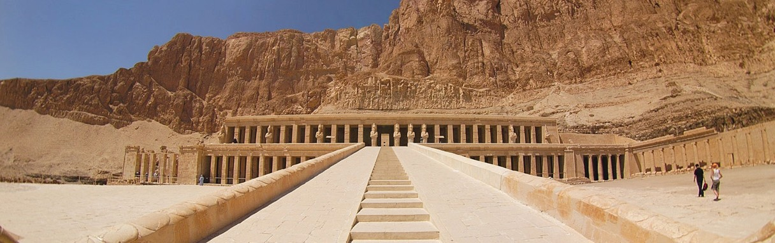Nov 18–28, 2017
Land & Air Included
from $3,999 per person

Over the 2017 Thanksgiving Holiday Season, travel with Bill Burgess to ancient Egypt and visit all the major sites - the pyramids, the only remaining 7 Wonders of the Ancient World, the Egyptian Museum with all dynasty treasures including King Tut just down the street from your 5-Star Luxury hotel with balcony views of the Nile and Giza Plateau, Spa and Casino, the Valley of the King and Queens, Ramsesian Temples of Abu Simbel, historic Greco-Roman
Alexandria of Cleopatra VII, and the famous Bazaar and Mosque of old Cairo. And more, enjoy
a luxurious 3-night cruise along the Nile River with all meals, shore excursions, and entertainment included while touring Thebes, Luxor, Aswan Dam, Edfu, Kom Ombo and their Art, monuments and temples. Uncover ancient history with experienced Guides and Bill Burgess, and his colleagues and friends. Bill is an Art Historian, Educator, and former Museum Director. He has studied in Egypt and traveled extensively around the world. Enjoy an experience of a lifetime and the height of Egyptian hospitality with your host.

3

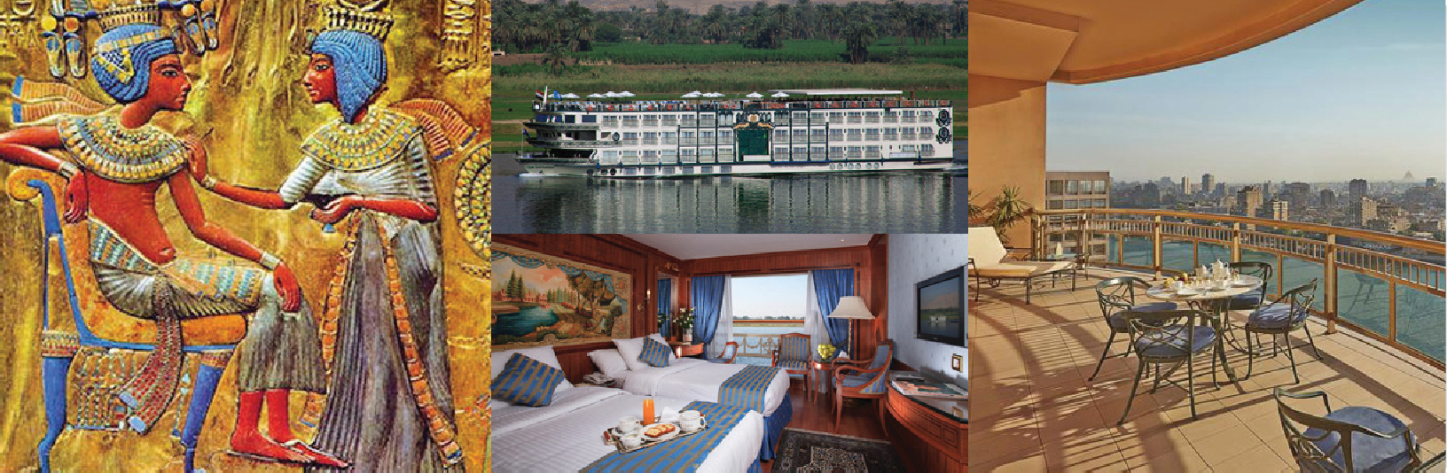
Timeless Egypt: Experience the Pyramids, Abu Simbel, Valley of the Kings and Queens, and a luxury 3-night Nile Cruise with Bill Burgess

Day 1: Cairo – Arrival

Price Includes :
- Roundtrip Non-Stop International Airfare from JFK including taxes & fees
- Domestic flights within Egypt
- Group arrival and departure transfers
- 6 nights accommodation at 5-star deluxe hotels in Cairo and Aswan
- 3-night Nile Cruise aboard the luxury Sonesta St. George
- Breakfast daily
- 2 dinners in Cairo and 1 dinner in Aswan
- Breakfast, lunch, and dinner on board our cruise ship
- Ground transportation by deluxe motor coach
- Entrance fees & luggage handling
- English-speaking guide throughout
- Customary tips to your guide and driver
- Entry Visa
- Day trip to Abu Simbel
Price Excludes :
- Optional Travel Insurance
- Personal Expenses
- Optional tour to Alexandria
Upon arrival to Cairo International Airport, we are met by our local represent- atives and transferred to our hotel in the city center. We will enjoy a welcome dinner at out hotel and overnight.
Day 2: Cairo – Full Day of Pyramids, Memphis, & Sphinx After breakfast, we meet our guide and visit the step pyramid in Sakkara, the pyramid of Unas, the Serapeum, and Memphis - the oldest capital of Egypt, and Alabaster Sphinx. We continue to the Great Pyramids of Cheops, Chefren and Mykerinos for a comprehensive tour. In the evening, we will return to our hotel in Cairo for an overnight stay.

Day 3: Cairo – Egyptian Museum, Citadel & Bazaar
After breakfast, we will experience a full day guided tour of Cairo. We start our journey at the Egyptian Museum, then continue to the world famous Citadel of Cairo. We end our day shopping at the Old Bazaar before return- ing to our hotel for an overnight stay.

Day 4: Cairo – Aswan – Abu Simbel – Aswan
After breakfast we are transferred to Cairo Airport to board a short flight
to Aswan, from where we will travel by bus to Abu Simbel to see the Great Temple of Ramses II and the smaller Temple of Hathor, Egypt’s most-visited sites after the Great Pyramids. We return to Aswan in the evening for dinner and an overnight stay at our hotel.

Day 5: Aswan (Cruise)
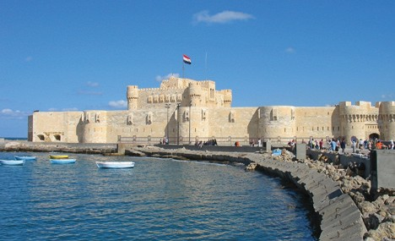
After breakfast, we are transferred to the port to embark on our Nile cruise. After lunch on board, we tour Aswan and visit the High Dam and the Temple of Philae, and sail along the Nile aboard a traditional Felucca, followed by afternoon tea on board. In the evening, we will attend the Captain’s wel- come cocktail, and enjoy dinner and a Nubian show on board. We will over- night in Aswan aboard our cruise ship.

Day 6: Aswan – Kom Ombo – Edfu
After breakfast on board, we sail to Kom Ombo and visit the Temple dedicat- ed to the two Gods Sobek and Haroeris. Later on, we sail to Edfu and enjoy lunch on board. In Edfu, we visit the temple of Horus, and then continue to Esna. We will enjoy dinner and an oriental Galabaya party aboard the ship tonight.

Day 6: Esna – Luxor
Early in the morning, we sail to Luxor and are served breakfast on board. We will visit the West Bank including the Temple of Queen Hatshepsut and the Valley of the Kings and Queens. We will have lunch on board followed by afternoon tea. We will enjoy a relaxing dinner on board and overnight while sailing along the Nile.

Day 8: Luxor – Cairo
After breakfast, we disembark our cruise and visit the Temple of Karnak and the Temple of Luxor on the East Bank. We are then transferred to the airport to board our flight back to Cairo. Upon arrival to Cairo, we are met and trans- ferred to our hotel. The remainder of the day is at leisure. We will overnight at our hotel in Cairo.

Day 9: Cairo – At Leisure (Optional Alexandria Tour)
After breakfast at our hotel, we have a full day at leisure in Cairo. Consider joining an optional private tour to the famous and beautiful city of Alexandria. We will see the Catacombs, Pompey’s Pillar, the Roman Theater and the Montazah Gardens. We will also visit the National Museum which
Terms and Conditions
Deposit and Final Payment:
Fabulous Italy: Journey with Bill Burgess through Rome, Florence & Venice
A deposit of $250 is due at booking ($100 is non-refundable). This deposit forms part of your final payment due 90 days prior to departure.
Cancellations:
Notice of cancellation must be made in writing directly to Key Tours. In addition to the non-refundable $100 portion of the deposit, a
$250 fee per person will be charged for all cancellations made within 90 days of departure.

Additionally, the following scale of charges will apply when cancellation notice occurs within 59 days of tour departure:

displays artifacts from the Egyptian, Hellenistic, Coptic, and Islamic periods.
Lunch is included during this optional tour. In the evening, we will gather | before services | of total service price
for a farewell dinner at our hotel in Cairo followed by an overnight stay. | 59–40 | 25%
Day 10: Cairo – Departure | 39–22 | 50%
After breakfast at our hotel, we are transferred to the airport to | 21–8 | 70%
 | 7–3 | 85%
 | Late Cancellations & No Show | 100%

Cancellations No. of days
Charges as a percentage

Land & Air from JFK
Double Room $3,999 per person
Single Room Supplement $900 per person

No refunds can be made for unused portions of any services

Smoking:
Smoking is not permitted in vehicles operated by Key Tours. Frequent stops are made so that smoke breaks may be taken outside vehicles.
Accommodation
□ Twin □ Single
Travel Order Form
- Optional Alexandria Tour with Lunch Included: +$125/person
Deposit
- $250 per person deposit due on or before March 15, 2017
Early Bird Special: Pay your initial deposit of $250 on or before February 15, 2017 to receive a $100/person reduction
- $500 per person second deposit due on or before May 15, 2017
Travel Insurance
- Sharing Double: $237 □ Sharing Double w/ Alexandria Tour: $264
- Single Room: $299 (with or without Alexandria Tour)
IMPORTANT: In order to ensure that any pre-existing medical conditions are covered, we strongly recommend that you purchase travel insurance when you pay your initial deposit.
Payment
- Check □ Credit Card (Visa, MasterCard, American Express, or Discover) The name on your Passport
Rooming with

Address
City
State
Zip
Best phone number to contact

Email: b@burgesstraveladventures.com

Check Payment Mail to:
Burgess Travel Adventures
P.O. Box 2224
New York, NY 10008-2224

Credit Card Payment: Please complete the attached form and send to: b@burgesstraveladventures.com
Young Tour Participants:
under the age of 18 cannot be accepted on these tours. Passport/visa:
Travelers will need a current passport valid until they return home. Please contact your destination country’s nearest consulate for updated details on visa requirements. Costs of visas and border crossing fees are the responsibility of the traveler.
Baggage:
Porterage for one suitcase is included in the tour price. Due to limited coach capacity, the single bag should not exceed the dimensions of 30”x18”x10” and not weigh more than 50lbs (23kg). A charge of US $4 per travelling day is collected by the tour director for each additional piece of baggage, or if the suitcase exceeds established weight and/or dimension limitations.

Timeless Egypt: Experience the Pyramids, Abu Simbel, Valley of the Kings and Queens, and a luxury 3-night Nile Cruise with Bill Burgess
