South Africa Zimbabwe & Victoria Falls
Price: $6,843.00 per person in double single supplement: $1,100.00

Day 1: Cape Town - Arrival
March 11-23, 2023 (11 days/10 nights Itinerary)

Day 8: Johannesburg & Soweto

Upon arrival to Cape Town International Airport, we will met by our local representative and transferred to our hotel in the heart of the city. Later, enjoy a welcome dinner at our hotel. (D)

Day 2: Cape Town - Robben Island & Kirstenbosch Botanical Garden
Transfer to the port for a ferry ride to Robben Island, where Nelson Mandela was imprisoned for 18 years. Continue to Kirst- enbosch Botanical Garden, the largest botanical garden in the Southern Hemisphere. Overnight in Cape Town.(B)

Day 3: Cape Town - Table Mountain - Drakenstein Weather permitting, take the cable car to the top of Table Mountain. Continue to Groot Drakenstein Prison, the last place in which Nelson Mandela was incarcerated. After a brief tour of Stellenbosch town, drive along the wine road and enjoy a wine tasting at a local vineyard. Continue to Franschhoek for lunch. (B,L)

Day 4: Cape Town - Cape Peninsula Tour
Depart for the little hamlet of Hout Bay. Taking a local boat, sail to Duikerg Island to see the famous Cape Fur Seals. Continue to Boulders Beach. Here, the African penguin colony attracts many visitors each year. After lunch, continue to the meeting place of
We will explore Johannesburg’s multiple facets during a guided tour. Continue to Soweto, which symbolized the struggle against segragated South Africa, where we will visit the museum of Apartheid. (B)

Day 9: Kruger - Victoria Falls
We are transferred to Kruger Airport to board our flight to Victo- ria Falls, Zimbabwe. Upon arrival, will be met and transferred to our hotel. (B)

Day 10: Victoria Falls
Today, enjoy a morning tour of Victoria Falls and enjoy the remainder of the day at leisure. In the evening, we will be transfered to the Zambezi River to board our sunset river cruise. A number of animals and species of birds can be viewed from the decks, and unlimited snacks and drinks are served (included) throughout. (B,D)

Day 11: Victoria Falls - Johannesburg - Departure We will be transferred to the airport to board our return flight home. (B)

Travel Order Form

the two oceans at Cape of Good Hope. Take the cable car to see
Accommodation □ Twin □ Single
Tour #: 108000

the most powerful lighthouse on the South African coast at Cape Point. (B,D)

Deposit □ $500 per person deposit due on Nov. 11, 2022 Final payment due Dec. 30, 2022

Day 5: Cape Town - Kruger National Park
Travel Insurance □ Sharing Double: $518
□ Single Room: $609
Ask for Early Bird Discount
$100 off

We will be transferred to the airport to board our flight to Kruger National Park. Upon arrival, we will be met and transferred to our safari lodge for lunch and a late afternoon game drive. (B,L,D)

Day 6: Kruger National Park
Start the day with an early morning game drive before breakfast. Enjoy lunch at our safari lodge, and then take a late afternoon game drive through the reserve. (B,L,D)

Day 7: Kruger National Park - Johannesburg
We will be transferred to the airport to board our flight to Johan- nesburg. Upon arrival, we will be met by our guide and, after lunch, taken on a visit of Satyagraha - Mohandas Gandhi’s house
IMPORTANT: In order to ensure that any pre-existing medical conditions are covered, we strongly recommend that you purchase travel insurance when you pay your initial deposit.
Payment □ Check □ Credit Card (Visa, MasterCard, American Express, or Discover) The name on your Passport

Rooming with

Address

City State Zip

Best phone number to contact Email

Please complete the payment form and send to: Credit Cards: Checks:

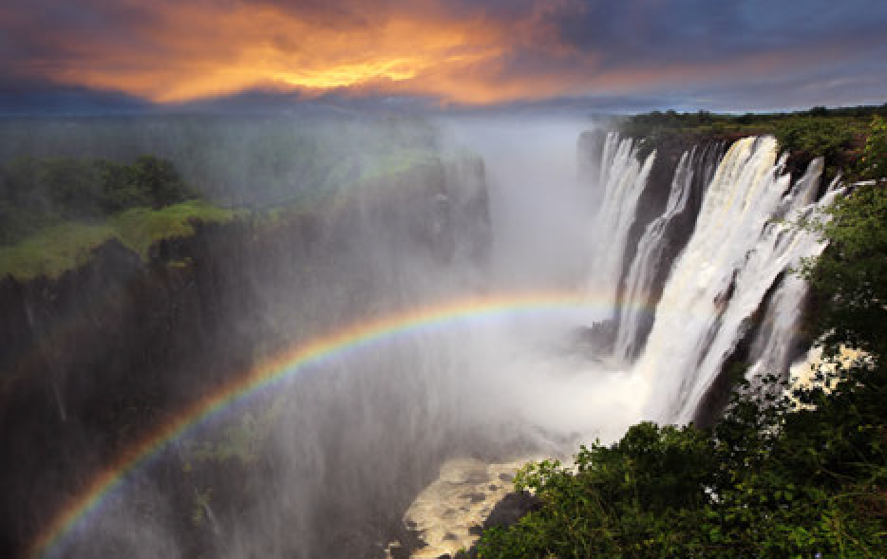and museum. (B)

Price Includes
- International roundtrip airfare from JFK
- 10 nights in 4-star accomodations
- Group arrival & departure transfers with English-speaking assitance
- Breakfast daily, 3 lunches and 5 dinners
- Sightseeing with licensed English-speaking guides
- Touring by deluxe A/C motor coach
- Entrance fees and luggage handling
- Two game drives in Kruger National Park
- Zambezi Cruise including unlimited drinks & snacks
Email: B@BurgessTravelAdventures.com
T:212.406.2400
F:212.406.2402

Burgess Travel Adventures
P.O. Box 2224
New York, NY 10008-2224

