New York
Church Street Station, P.O. Box 2224, New York, NY 10008-2224
Tel: 212.406.2400
Fax: 212.406.2402

Email: B@BurgessFineArts.com
Website: www.BurgessTravelAdventures.com

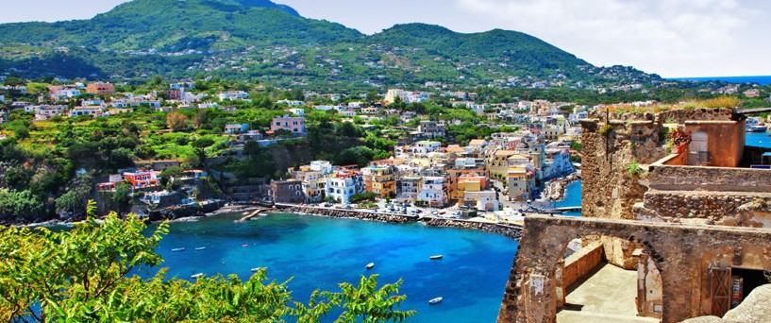
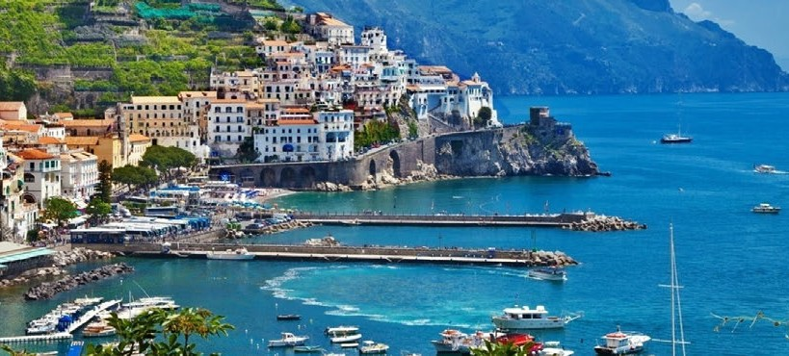
More Fabulous Italy: Amalfi Coast, Ischia & Sicily
October 12-20, 2018
$3,999 per person
Double-Including Air and all Tips & taxes.
Single Supplement $835 9 days, 8 nights

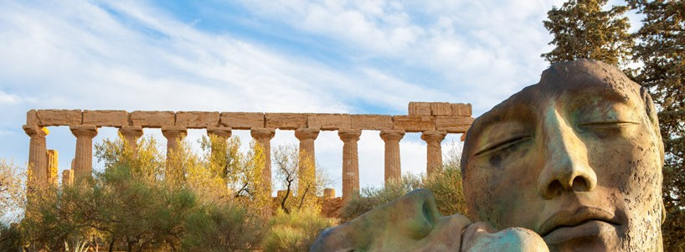
Burgess Travel Adventures and Keytours Vacations
presents
More Fabulous Italy: Travel Again with Bill Burgess to Amalfi Coast, Ischia & Sicily
October 12-20, 2018
From 3,999 per person

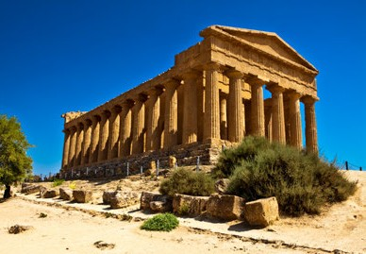

More Fabulous Italy: Amalfi Coast, Ischia & Sicily

Day 1: October 12 - NYC/JFK to Rome
Exclusive Tour price includes:
- R/T Non-Stop air from NYC- Italy
- R/T Airport transfers English speaking guide
- Accommodations in First Class Hotels
- Local taxes and service fees
- Daily buffet breakfast
- 3 Dinners including a Welcome and Farewell Dinner with entertainment
- 3 lunches as indicated on the Itinerary
- In depth Sightseeing with local guides
- Wine tasting
- Olive Oil and olive tasting
- Cooking Class
- Wine- 2 glasses with lunch and dinner, mineral water, coffee and tea
- Touring by air conditioned motor coach
- Tour Director
- Customary Tips to Tour Manager and driver
Price Excludes :
- Optional Travel Insurance
- Optional Tours Ishia- thermal visit
- Personal Expenses

Day 2: Rome - October 13 - Arrive Naples - Met by our local representative and transferred your to hotel in Sorrento with Pizza lunch and visit to the ancient Roman of Herculaneum, after check in rest of the day is at leisure. Tonight a welcome dinner-HOTEL-Michelangelo- Lunch included

Day 3: Rome -October 14- After breakfast we drive and visit Positano,a wonderful fisherman’s town and then continue to Amalfi, then visit Villa Rufolo, inspiration for many artists, Overnight at Sorrento hotel

Day 4: - October 15 -Sorrento-day trip with lunch to Ischia-or a day to relax along the fantastic shoreline. Optional Tour to Island of Ischia for Thermal Spa Treatment at Resort (price not included).

Day 5: - October 16- Sorrento-Naples-Catania-Taormina-Sicily-Transfer to Naples for the short morning flight to Catania-enjoy an afternoon panoramic tour of Taormina then dinner at local restaurant tonight- HOTEL-Grand Hotel Miramare

Day 6 - October 17 - Taormina-Siracusa-Taormina-today we visit one of the most powerful Greek cities in the Mediterranean then visit to vineyars of Zisola and Noto Cathedral. Lunch and overnight in Taormina hotel

Day 7 October 18-Taormina-Agrigento-Palermo After breakfast we leave this lovely city and stop at valley of Temples, enjoy a leisurely lunch and then drive to Palermo-HOTEL-Best Western-Cavaleri

Day 8 October 19-Palermo and Monreale-After breakfast we depart and visit the cathedral, after we go back to Palermo for the city tour or a cooking class-Farewell dinner and local songs O/N in Hotel-

Day 9 October 20-After Breakfast-Transfer to airport for flight home

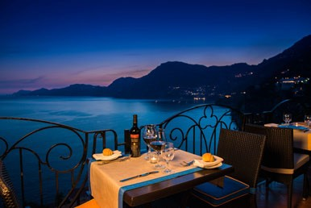
Land & Air from JFK

Double Room $3999 per person

Single Room Supplement $835 per person

Terms and Conditions
Travel Order Form
Accommodation Single Supplement $835
□ Twin □ Single
Deposit

□ $500 per person deposit due on March 31st 2018.

Final payment due June 30th, 2018 Call Keytours 1-800-576-1784 x100

Travel Insurance
□ Sharing Double: $237 □ Sharing Double: $264 □ Single Room: $353 with or without
with any optional any optional sightseeing
sightseeing
IMPORTANT: In order to ensure that any pre-existing medical conditions are covered, we strongly recommend that you purchase travel insurance when you pay your initial deposit.

Payment
□ Check □ Credit Card (Visa, MasterCard, American Express, or Discover) The name on your Passport
Rooming with

Address
City
State
Zip
Best phone number to contact
Email: b@burgesstraveladventures.com

Check Payment Mail to:
Burgess Travel Adventures
P.O. Box 2224
New York, NY 10008-2224
Credit Card Payment: Please complete the attached form and send to: b@burgesstraveladventures.com
Tel.212.406.2400
Fax.212.406.2402
Attn: Groups Dept
Deposit and Final Payment:
A non-refundable deposit of $500 per person is due upon booking. This deposit forms part of your final payment due by March 31st.

Cancellations:
Notice of cancellation must be made in writing directly to Key Tours. In addition to the non-refundable $500 deposit, the following scale of charges will apply when cancellation notice occurs within 59 days of tour departure:

Cancellations No. of days before services | Charges as a percentage of total service price
59–40 | 25%
39–22 | 50%
21–8 | 70%
7–3 | 85%
Late Cancellations & No Show | 100%

No refunds can be made for unused portions of any services.

Smoking:
Smoking is not permitted in vehicles operated by Key Tours. Frequent stops are made so that smoke breaks may be taken outside vehicles.
Young Tour Participants:
under the age of 18 cannot be accepted on these tours. Passport/visa:
Travelers will need a current passport valid until they return home.
Baggage:
Porterage for one suitcase is included in the tour price. Due to limited coach capacity, the single bag should not exceed the dimensions of 30”x18”x10” and not weigh more than 50lbs (23kg). A charge of US $4 per travelling day is collected by the tour director for each additional piece of baggage, or if
the suitcase exceeds established weight and/or dimension limitations.

More Fabulous Italy: Amalfi Coast, Ischia & Sicily

